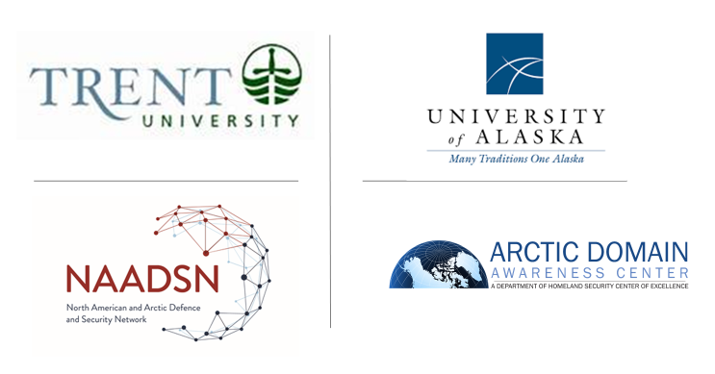
Moderator and Note Taker Information
17-18 September 2020 Advancing Collaboration in Canada-U.S. Arctic Regional Security (ACCUSARS)

As of 13 Sep 2020

Introduction:

Two Arctic research-focused teams, the Arctic Domain Awareness Center (ADAC), a U.S. Department of Homeland Security Center of Excellence in Maritime Research, who is hosted by the University of Alaska Anchorage, and the North American and Arctic Defence and Security Network, (NAADSN) who is hosted by Trent University, in Peterborough Ontario, are seeking to advance a baseline understanding of the current state of security in the Arctic. This baseline will allow further investigation into the complex risks affecting the North American Arctic.

Respectful guidance:

The following is the Breakout Group Moderator and Note Taker Instructional Information for ADAC and NAADSN’s 2020 “Advancing Collaboration in Canada-U.S. Arctic Regional Security (ACCUSARS)” workshop planned for 17-18 Sep 2020, via Zoom.

The principle goal of each breakout group is to elicit relevant research questions from the group, informed by associated plenary sessions.

Note as a virtual conference, the conference coordinators will place participants into breakout groups and return to the plenary session, using the Zoom application.

Each breakout group is planned to have 1 x Moderator and a minimum of 1 x Note taker. Each recorder will accomplish taking notes. Each breakout group’s facilitator team will decide who will present for the group as appropriate for the plenary sessions. Recommend a participant other than the moderator or note taker present during such sessions

The ACCUSARS planning team recognizes the critical role that Moderators and Note takers provide in a successful workshop and offers the following suggestions to aid the work requested to be accomplished during the breakout session:

- Establish a group dynamic by a brief round of personal introductions…and solicit in the introductions, fellow team member’s qualifications/experience in addressing the specific topic of the session.
- State the desired outcome of the breakout groups. ACCUSARS is focused on identifying the current state of security, principally focused on the North American Arctic, and identifying shortfalls and gaps in strategy, planning, coordination, policy, science and education. The outcomes should help inform future endeavors, to include research.

- Finding a way to advance Delphi prioritization. A challenge for the breakout groups are to address a way to get priorities in order to gain group participation. Normally this is done by writing recommendations on butcher block and using color coded labels to gain the group’s priorities. In a virtual medium this means the Moderator and/or recorder will have to share their screen and solicit voting virtually. Respect, patience and courtesy will need to be provided to participants to gain their trust to get their vote.

- Brainstorm to gain insights from the team to address the topics of discussion. It is not critical to accomplish all the topics in great detail, but it is requested that each breakout group address all topics at least in a summary fashion.
- Moderators...please share your screen...please use this to keep track of major themes and ideas. You may use the software of your choice, but this allows Delphi voting! If/as desired, you can assign someone to type for you, but that usually lessons your influence...in sum, the person who owns the “pen” directs the team and the focus.
- Recorders: please type all notes in Microsoft Word and ensure you have all the administrative information included pertaining to your group. This is critical and often overlooked.
- Recorders: Once the topics have been addressed, it may be helpful to develop an outline in order to structure the report for the close of the workshop.
- Moderators...ensure the note taker has time to capture the needed/salient points of discussion. If/as needed, review the prior elements of conversation to ensure the needed details are appropriately documented.
- Challenge members to stay focused on through a session. If a member has to depart, ask them to either depart before of following a session to avoid deflating and de-energizing group investment in accomplishing the task of developing the research questions.
- Outline what success should look like: Strategic Foresight Activity (17 September) is to identify the primary indicators of risk and threat within the North American Arctic. Outcomes for your breakout group should be aligned with your group’s assigned theme (political, human, economic/resources, and environment). Settling North American Research Priorities (18 September) is focused on identifying the research questions and technology capabilities needed to support CANUS objectives in the Arctic.
- Seek to avoid drifting into areas that are the associated topics of discussion…ACCUSARS seeks to illuminate risks/threats that are typically ignored because they are not direct, military or political security challenges to sovereignty.
- When the team appears stuck and not able to move…take a break and reset.
- Seek to gain all members participation. Often the quiet members hold the most compelling ideas. Concurrently, seek to avoid domination of those members who are the most forceful and perhaps the most enlightened, often their experience is a reflection of what is already known, not of what is yet to be understood.
- The latter part of the breakout group-focus the team to help create the report for the Moderator.
- Moving faster than schedule is ok. If all workgroups finish early, the workshop will finish early. Correspondingly, moving slower than schedule will unfortunately not be helpful. Trim and focus (and the workshop hosts will help as needed) to keep close as possible to on-time.

In closing, help folks to enjoy the discussion…light-hearted tones and encouragement usually help gain the best and brightest a person has to offer.

Sincerely,

The UA Arctic Domain Awareness Center Team, and

The North American Arctic Defence and Security Network Team

